# Parameter Sweep (Latin Hypercube Sample) with education

NOTE: both of these models are problematic because of the high multicollinearity. I suggest our next step to be a principle components analysis and SEM based on this to tease out different effects.

This validation type takes a sample of all the possibilities for our model and runs it. This lets us better understand the way our system works under all conditions. This is useful in some ways, but let’s keep in mind how, given the range of all possible conditions, how many of them might be applicable to understanding society as it operates today.

## Regression of all variables against godBelief

First, the regression with all variables, including supernatualBelief

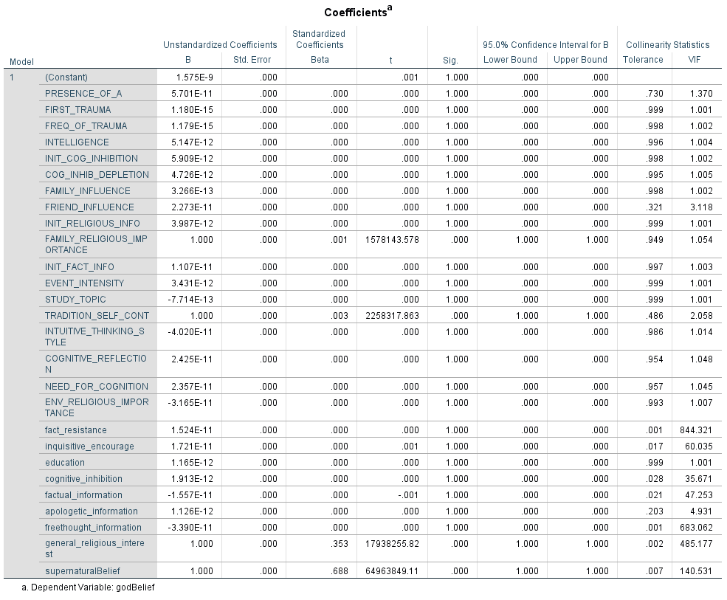

Now without supernaturalBelief and without general_religious_interest. Both of which were removed because they were significant but had insane VIF

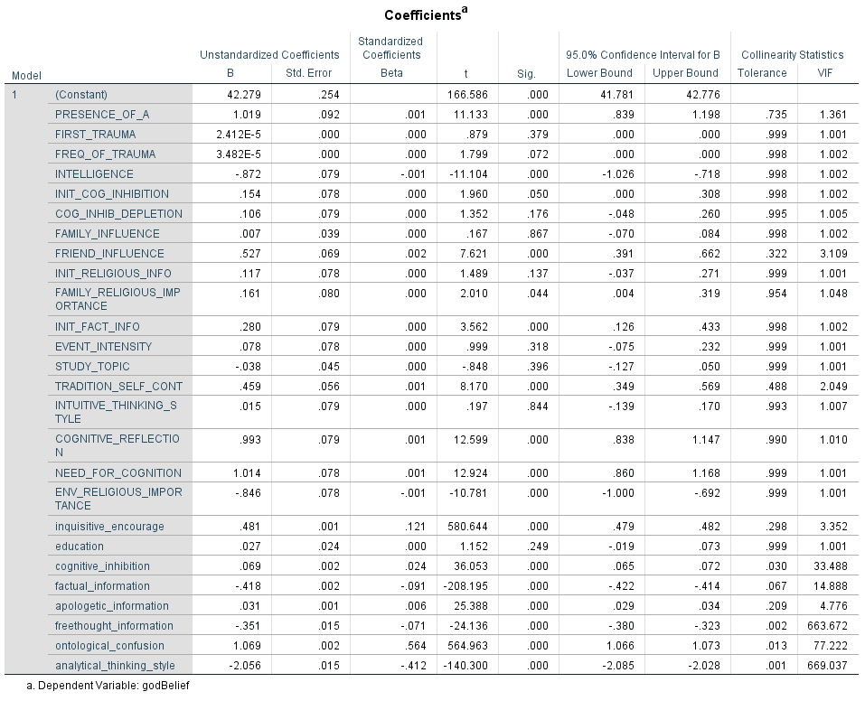

God belief is significantly influenced positively by ontological confusion, presence of atheists, friend (but not family) influence, family religious importance, tradition and self continuity, cognitive reflection, need for cognition, inquisitive encouragement, cognitive inhibition, apologetic information, and ontological confusion as well as negatively by analytical thinking style, free thought information, factual information, environmental religious importance, and intelligence.

## Regression of all variables against supernaturalBelief

All variables against supernaturalBelief

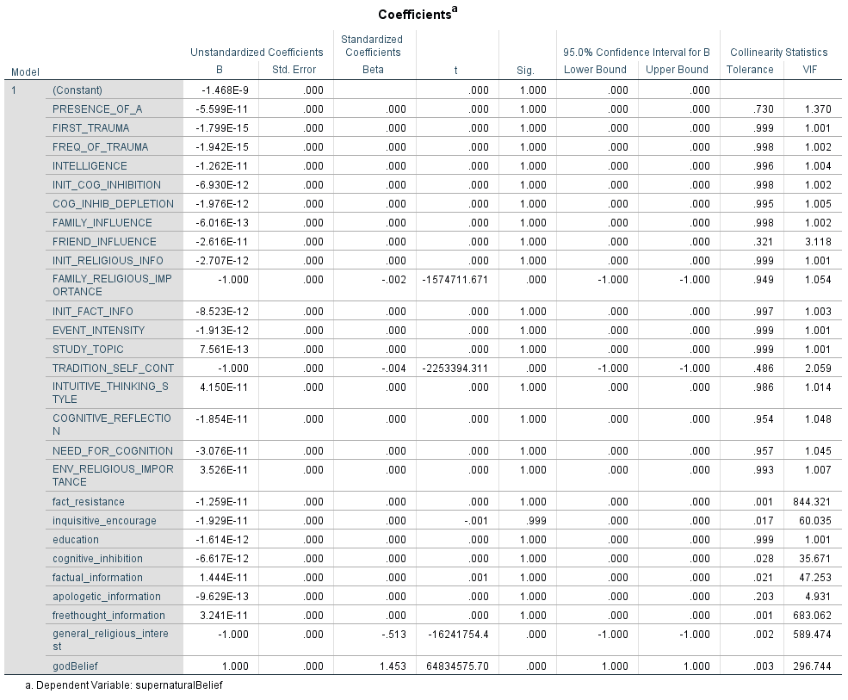

Due to high VIF, godBelief and general_religious_interest are removed.

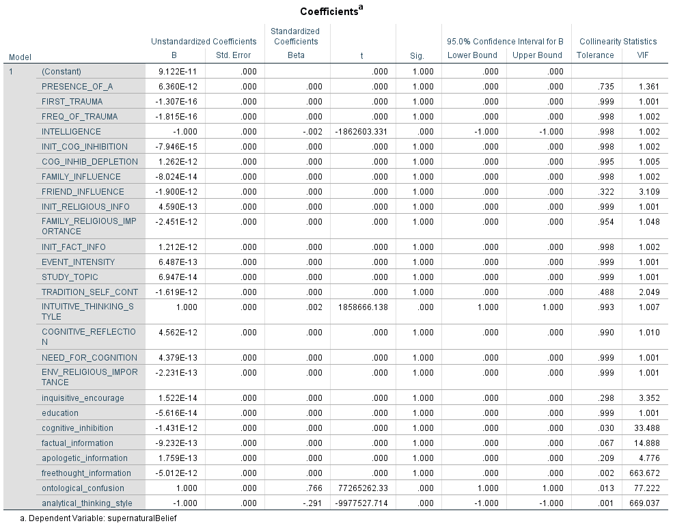

Supernatural belief is significantly (and positively) influenced by ontological confusion and intuitive thinking style and negatively influenced by intelligence and analytical thinking style.

## God belief vs supernatural belief

|  |  |  |  |  |
| --- | --- | --- | --- | --- |
| **Correlations** | | | | |
|  | | | godBelief | supernaturalBelief |
| Spearman's rho | godBelief | Correlation Coefficient | 1.000 | .850** |
| Sig. (2-tailed) | . | .000 |
| N | 20000 | 20000 |
| supernaturalBelief | Correlation Coefficient | .850** | 1.000 |
| Sig. (2-tailed) | .000 | . |
| N | 20000 | 20000 |
| **. Correlation is significant at the 0.01 level (2-tailed). | | | | |

## Education difference by study_topic

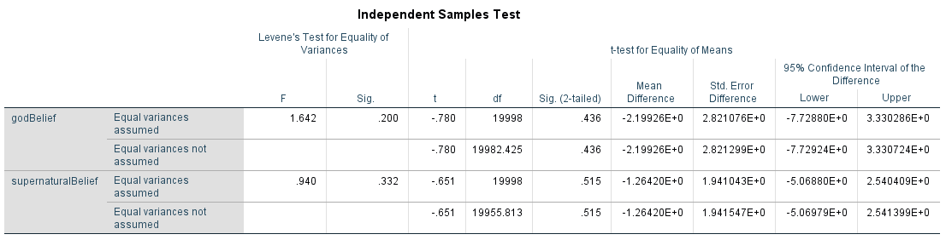

# Parameter Sweep (Latin Hypercube Sample) without education

## Regression of all variables against godBelief

|  |  |  |  |  |  |  |  |  |
| --- | --- | --- | --- | --- | --- | --- | --- | --- |
| **Coefficientsa** | | | | | | | | |
| Model | | Unstandardized Coefficients | | Standardized Coefficients | t | Sig. | 95.0% Confidence Interval for B | |
| B | Std. Error | Beta | Lower Bound | Upper Bound |
| 1 | (Constant) | 1.809E-10 | .000 |  | .000 | 1.000 | .000 | .000 |
| PRESENCE_OF_A | 7.271E-12 | .000 | .000 | .000 | 1.000 | .000 | .000 |
| INTELLIGENCE | -1.000 | .000 | -.001 | -1723066.986 | .000 | -1.000 | -1.000 |
| INIT_COG_INHIBITION | 7.600E-13 | .000 | .000 | .000 | 1.000 | .000 | .000 |
| COG_INHIB_DEPLETION | 8.344E-13 | .000 | .000 | .000 | 1.000 | .000 | .000 |
| FAMILY_INFLUENCE | -6.579E-13 | .000 | .000 | .000 | 1.000 | .000 | .000 |
| FRIEND_INFLUENCE | 9.752E-12 | .000 | .000 | .000 | 1.000 | .000 | .000 |
| INIT_RELIGIOUS_INFO | 2.183E-13 | .000 | .000 | .000 | 1.000 | .000 | .000 |
| FAMILY_RELIGIOUS_IMPORTANCE | 1.000 | .000 | .001 | 1687173.294 | .000 | 1.000 | 1.000 |
| INIT_FACT_INFO | 1.172E-12 | .000 | .000 | .000 | 1.000 | .000 | .000 |
| TRADITION_SELF_CONT | 1.000 | .000 | .003 | 2379313.145 | .000 | 1.000 | 1.000 |
| INTUITIVE_THINKING_STYLE | 1.000 | .000 | .001 | 1711027.712 | .000 | 1.000 | 1.000 |
| COGNITIVE_REFLECTION | 5.654E-12 | .000 | .000 | .000 | 1.000 | .000 | .000 |
| NEED_FOR_COGNITION | 1.622E-12 | .000 | .000 | .000 | 1.000 | .000 | .000 |
| ENV_RELIGIOUS_IMPORTANCE | -2.107E-12 | .000 | .000 | .000 | 1.000 | .000 | .000 |
| inquisitive_encourage | 2.221E-13 | .000 | .000 | .000 | 1.000 | .000 | .000 |
| cognitive_inhibition | -1.801E-12 | .000 | .000 | .000 | 1.000 | .000 | .000 |
| factual_information | -1.796E-12 | .000 | .000 | .000 | 1.000 | .000 | .000 |
| apologetic_information | 1.805E-13 | .000 | .000 | .000 | 1.000 | .000 | .000 |
| ontological_confusion | 1.000 | .000 | .550 | 66515084.510 | .000 | 1.000 | 1.000 |
| general_religious_interest | 1.000 | .000 | .346 | 19885323.110 | .000 | 1.000 | 1.000 |
| analytical_thinking_style | -1.000 | .000 | -.196 | -13711692.150 | .000 | -1.000 | -1.000 |
| a. Dependent Variable: godBelief | | | | | | | | |

## Regression of all variables against supernaturalBelief

|  |  |  |  |  |  |  |  |  |
| --- | --- | --- | --- | --- | --- | --- | --- | --- |
| **Coefficientsa** | | | | | | | | |
| Model | | Unstandardized Coefficients | | Standardized Coefficients | t | Sig. | 95.0% Confidence Interval for B | |
| B | Std. Error | Beta | Lower Bound | Upper Bound |
| 1 | (Constant) | -1.090E-10 | .000 |  | .000 | 1.000 | .000 | .000 |
| PRESENCE_OF_A | -7.139E-12 | .000 | .000 | .000 | 1.000 | .000 | .000 |
| INTELLIGENCE | -1.000 | .000 | -.002 | -1551284.262 | .000 | -1.000 | -1.000 |
| INIT_COG_INHIBITION | 1.344E-12 | .000 | .000 | .000 | 1.000 | .000 | .000 |
| COG_INHIB_DEPLETION | 9.251E-13 | .000 | .000 | .000 | 1.000 | .000 | .000 |
| FAMILY_INFLUENCE | -1.004E-12 | .000 | .000 | .000 | 1.000 | .000 | .000 |
| FRIEND_INFLUENCE | -9.337E-12 | .000 | .000 | .000 | 1.000 | .000 | .000 |
| INIT_RELIGIOUS_INFO | 2.984E-13 | .000 | .000 | .000 | 1.000 | .000 | .000 |
| FAMILY_RELIGIOUS_IMPORTANCE | 1.751E-12 | .000 | .000 | .000 | 1.000 | .000 | .000 |
| INIT_FACT_INFO | -2.107E-12 | .000 | .000 | .000 | 1.000 | .000 | .000 |
| TRADITION_SELF_CONT | 3.046E-13 | .000 | .000 | .000 | 1.000 | .000 | .000 |
| INTUITIVE_THINKING_STYLE | 1.000 | .000 | .002 | 1540445.255 | .000 | 1.000 | 1.000 |
| COGNITIVE_REFLECTION | 1.949E-12 | .000 | .000 | .000 | 1.000 | .000 | .000 |
| NEED_FOR_COGNITION | -5.134E-12 | .000 | .000 | .000 | 1.000 | .000 | .000 |
| ENV_RELIGIOUS_IMPORTANCE | 2.812E-12 | .000 | .000 | .000 | 1.000 | .000 | .000 |
| inquisitive_encourage | -3.535E-12 | .000 | .000 | .000 | 1.000 | .000 | .000 |
| cognitive_inhibition | -3.745E-12 | .000 | .000 | .000 | 1.000 | .000 | .000 |
| factual_information | 1.042E-12 | .000 | .000 | .000 | 1.000 | .000 | .000 |
| apologetic_information | 1.782E-14 | .000 | .000 | .000 | 1.000 | .000 | .000 |
| ontological_confusion | 1.000 | .000 | .784 | 59883802.930 | .000 | 1.000 | 1.000 |
| general_religious_interest | 7.479E-12 | .000 | .000 | .000 | 1.000 | .000 | .000 |
| analytical_thinking_style | -1.000 | .000 | -.280 | -12344692.590 | .000 | -1.000 | -1.000 |
| a. Dependent Variable: supernaturalBelief | | | | | | | | |

## God belief vs supernatural belief

|  |  |  |  |  |
| --- | --- | --- | --- | --- |
| **Correlations** | | | | |
|  | | | godBelief | supernaturalBelief |
| Spearman's rho | godBelief | Correlation Coefficient | 1.000 | .857** |
| Sig. (2-tailed) | . | .000 |
| N | 20000 | 20000 |
| supernaturalBelief | Correlation Coefficient | .857** | 1.000 |
| Sig. (2-tailed) | .000 | . |
| N | 20000 | 20000 |
| **. Correlation is significant at the 0.01 level (2-tailed). | | | | |

## Education difference by study_topic

|  |  |  |  |  |  |  |  |  |  |  |
| --- | --- | --- | --- | --- | --- | --- | --- | --- | --- | --- |
| **Independent Samples Test** | | | | | | | | | | |
|  | | Levene's Test for Equality of Variances | | t-test for Equality of Means | | | | | | |
| F | Sig. | t | df | Sig. (2-tailed) | Mean Difference | Std. Error Difference | 95% Confidence Interval of the Difference | |
| Lower | Upper |
| godBelief | Equal variances assumed | .001 | .972 | .185 | 19998 | .853 | 5.340622490000000E-001 | 2.884893788000000E+000 | -5.120567917000001E+000 | 6.188692415000000E+000 |
| Equal variances not assumed |  |  | .185 | 19990.285 | .853 | 5.340622490000000E-001 | 2.883750569000000E+000 | -5.118327246000001E+000 | 6.186451744000000E+000 |
| supernaturalBelief | Equal variances assumed | .183 | .668 | -.062 | 19998 | .951 | -1.250102310000000E-001 | 2.023404779000000E+000 | -4.091050765000000E+000 | 3.841030303000000E+000 |
| Equal variances not assumed |  |  | -.062 | 19914.329 | .951 | -1.250102310000000E-001 | 2.021690509000000E+000 | -4.087691663000000E+000 | 3.837671201000000E+000 |

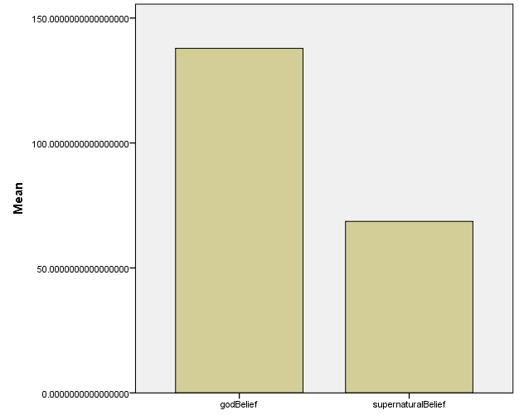

# Optimization Results with education

In order to better understand the conditions that result in different patterns, we asked the computer model to find the conditions that maximize and minimize different aspects of the model’s output.

There were four key optimizations that our team was interested in: max rel min spirit; max rel max spirit; min rel max spirit; min rel min spirit; and zero belief. These optimizations only looked to have the criteria met at the last value of the simulation.

All optimizations swept the same parameter space, as defined in the table below.

|  |  |  |  |
| --- | --- | --- | --- |
| Variable | Min | Max | Step |
| STARTING_AGE | 8 | 8 | 0 |
| PRESENCE_OF_A | 0 | 1 | 0.1 |
| FIRST_TRAUMA | 260 | 3120 | 104 |
| FREQ_OF_TRAUMA | 104 | 4160 | 104 |
| INTELLIGENCE | 0 | 1 | 0.1 |
| INIT_COG_INHIBITION | 0 | 1 | 0.1 |
| COG_INIHIB_DEPLETION | 0 | 1 | 0.1 |
| FAMILY_INFLUENCE | -1 | 1 | 0.1 |
| FRIEND_INFLUENCE | -1 | 1 | 0.1 |
| INIT_RELIGIOUS_INFO | 0 | 1 | 0.1 |
| FAMILY_RELIGIOUS_IMPORTANCE | 0 | 1 | 0.1 |
| INIT_FACT_INFO | 0 | 1 | 0.1 |
| EVENT_INTENSITY | 0 | 1 | 0.1 |
| START_HS_AGE | 6 | 6 | 0 |
| END_HS_AGE | 18 | 18 | 0 |
| START_UG_AGE | 19 | 19 | 0 |
| START_PG_AGE | 26 | 26 | 0 |
| END_UG_AGE | 23 | 23 | 0 |
| STUDYTOPIC | 0 | 1 | 0.1 |
| TRADITION_SELF_CONT | -1 | 1 | 0.1 |
| INTUITIVE_THINKING_STYLE | 0 | 1 | 0.1 |
| COGNITIVE_REFLECTION | 0 | 1 | 0.1 |
| NEED_FOR_COGNITION | 0 | 1 | 0.1 |
| ENV_RELIGIOUS_IMPORTANCE | 0 | 1 | 0.1 |

The results are included in the table below and individual results are included in the subsequent sections. All simulations had the same starting age (6). However, the educational level was varied where all simulations simulated high school attendance (EDUCATION_VAR = 0) while some also simulated high school and undergraduate attendance (EDUCATION_VAR = 1), and others simulated education through to postgraduate (EDUCATION_VAR = 2). The settings for this can be found in the table below. If a specific educational level was not simulated in a run, the value was changed to 100, which is after the simulation was programmed to stop running and therefore would not take effect.

|  |  |
| --- | --- |
| START_HS_AGE | 6 |
| END_HS_AGE | 18 |
| START_UG_AGE | 19 |
| START_PG_AGE | 26 |
| END_UG_AGE | 23 |

The table below depicts the optimal parameter settings (in each row) for each of the settings we prescribed it (in the columns). What this gives us is the conditions under which the output of the model best matches the desired outcome (our setting trying to maximize or minimize some target value)



## MaxRelMinSpirit

This optimization looked to find the conditions under which the simulation ends with the highest amount of god belief and the lowest amount of supernatural belief.

The conditions that best satisfied this condition were:

|  |  |
| --- | --- |
| Variable | Value |
| STARTING_AGE | 8 |
| PRESENCE_OF_A | 0 |
| FIRST_TRAUMA | 988 |
| FREQ_OF_TRAUMA | 2,288 |
| INTELLIGENCE | 1 |
| INIT_COG_INHIBITION | 0 |
| COG_INHIB_DEPLETION | 0.6 |
| FAMILY_INFLUENCE | 1 |
| FRIEND_INFLUENCE | -1 |
| INIT_RELIGIOUS_INFO | 1 |
| FAMILY_RELIGIOUS_IMPORTANCE | 1 |
| INIT_FACT_INFO | 1 |
| EVENT_INTENSITY | 0.2 |
| START_HS_AGE | 6 |
| END_HS_AGE | 18 |
| START_UG_AGE | 19 |
| START_PG_AGE | 26 |
| END_UG_AGE | 23 |
| STUDYTOPIC | 1 |
| TRADITION_SELF_CONT | 1 |
| INTUITIVE_THINKING_STYLE | 0 |
| COGNITIVE_REFLECTION | 1 |
| NEED_FOR_COGNITION | 0 |
| ENV_RELIGIOUS_IMPORTANCE | 0 |
| LHS_RUN | 0 |
| EDUCATION_VAR | 2 |

Objective 104

## MaxRelSpirit

|  |  |
| --- | --- |
| Variable | Value |
| STARTING_AGE | 8 |
| PRESENCE_OF_A | 0 |
| FIRST_TRAUMA | 3,172 |
| FREQ_OF_TRAUMA | 104 |
| INTELLIGENCE | 0 |
| INIT_COG_INHIBITION | 0 |
| COG_INHIB_DEPLETION | 1 |
| FAMILY_INFLUENCE | -0.1 |
| FRIEND_INFLUENCE | -1 |
| INIT_RELIGIOUS_INFO | 1 |
| FAMILY_RELIGIOUS_IMPORTANCE | 1 |
| INIT_FACT_INFO | 1 |
| EVENT_INTENSITY | 0 |
| START_HS_AGE | 6 |
| END_HS_AGE | 18 |
| START_UG_AGE | 19 |
| START_PG_AGE | 26 |
| END_UG_AGE | 23 |
| STUDYTOPIC | 0 |
| TRADITION_SELF_CONT | 1 |
| INTUITIVE_THINKING_STYLE | 1 |
| COGNITIVE_REFLECTION | 0 |
| NEED_FOR_COGNITION | 0 |
| ENV_RELIGIOUS_IMPORTANCE | 0 |
| LHS_RUN | 0 |
| EDUCATION_VAR | 2 |

Objective: 8298

## MinRelMaxSpirit

|  |  |
| --- | --- |
| Variable | Value |
| STARTING_AGE | 8 |
| PRESENCE_OF_A | 0.603 |
| FIRST_TRAUMA | 988 |
| FREQ_OF_TRAUMA | 3,432 |
| INTELLIGENCE | 0 |
| INIT_COG_INHIBITION | 0.6 |
| COG_INHIB_DEPLETION | 0.8 |
| FAMILY_INFLUENCE | 1 |
| FRIEND_INFLUENCE | -0.6 |
| INIT_RELIGIOUS_INFO | 0 |
| FAMILY_RELIGIOUS_IMPORTANCE | 0 |
| INIT_FACT_INFO | 0.8 |
| EVENT_INTENSITY | 0 |
| START_HS_AGE | 6 |
| END_HS_AGE | 18 |
| START_UG_AGE | 19 |
| START_PG_AGE | 26 |
| END_UG_AGE | 23 |
| STUDYTOPIC | 0 |
| TRADITION_SELF_CONT | -1 |
| INTUITIVE_THINKING_STYLE | 0.6 |
| COGNITIVE_REFLECTION | 0 |
| NEED_FOR_COGNITION | 0 |
| ENV_RELIGIOUS_IMPORTANCE | 0 |
| LHS_RUN | 0 |
| EDUCATION_VAR | 1 |

Objective 2.997

## MinRelSpirit

|  |  |
| --- | --- |
| Variable | Value |
| STARTING_AGE | 8 |
| PRESENCE_OF_A | 0.4 |
| FIRST_TRAUMA | 260 |
| FREQ_OF_TRAUMA | 1,352 |
| INTELLIGENCE | 1 |
| INIT_COG_INHIBITION | 0 |
| COG_INHIB_DEPLETION | 0 |
| FAMILY_INFLUENCE | 0.4 |
| FRIEND_INFLUENCE | -0.4 |
| INIT_RELIGIOUS_INFO | 0.9 |
| FAMILY_RELIGIOUS_IMPORTANCE | 0 |
| INIT_FACT_INFO | 1 |
| EVENT_INTENSITY | 0 |
| START_HS_AGE | 6 |
| END_HS_AGE | 18 |
| START_UG_AGE | 19 |
| START_PG_AGE | 26 |
| END_UG_AGE | 23 |
| STUDYTOPIC | 0 |
| TRADITION_SELF_CONT | -1 |
| INTUITIVE_THINKING_STYLE | 0 |
| COGNITIVE_REFLECTION | 1 |
| NEED_FOR_COGNITION | 1 |
| ENV_RELIGIOUS_IMPORTANCE | 0.1 |
| LHS_RUN | 0 |
| EDUCATION_VAR | 0 |

Objective: -10.7

## ZeroBelief

|  |  |
| --- | --- |
| Variable | Value |
| STARTING_AGE | 8 |
| PRESENCE_OF_A | 0.1 |
| FIRST_TRAUMA | 260 |
| FREQ_OF_TRAUMA | 104 |
| INTELLIGENCE | 0.4 |
| INIT_COG_INHIBITION | 0 |
| COG_INHIB_DEPLETION | 0.4 |
| FAMILY_INFLUENCE | 0.6 |
| FRIEND_INFLUENCE | 0 |
| INIT_RELIGIOUS_INFO | 0 |
| FAMILY_RELIGIOUS_IMPORTANCE | 0.2 |
| INIT_FACT_INFO | 0.2 |
| EVENT_INTENSITY | 0.2 |
| START_HS_AGE | 6 |
| END_HS_AGE | 18 |
| START_UG_AGE | 19 |
| START_PG_AGE | 26 |
| END_UG_AGE | 23 |
| STUDYTOPIC | 0 |
| TRADITION_SELF_CONT | -0.3 |
| INTUITIVE_THINKING_STYLE | 0 |
| COGNITIVE_REFLECTION | 0.2 |
| NEED_FOR_COGNITION | 0.5 |
| ENV_RELIGIOUS_IMPORTANCE | 0.2 |
| LHS_RUN | 0 |
| EDUCATION_VAR | 0 |

Objective: -2

# Longitudinal Calibrations with education

In order to better understand our model, we ran calibration experiments where we asked the computer model to match the output of the variable godBelief against an idealized set of outputs that represent different phenomena. Each of these are presented below.

|  |  |
| --- | --- |
| Setting | Pattern |
| AlwaysAtheist | always at 0' |
| AlwaysStrongAtheist | always at -500' |
| AlwaysReligious | always at 500' |
| Religious2AtheistConv | 500 to 0 at age 20' |
| Religious2AtheistConvLate | 500 to 0 at half way' |
| Atheist2ReligiousConv | 0 to 500 at age 20' |
| Atheist2RelConvLate | 0 to 500 at half way' |
| Atheist2RelConvVERYlate | 0 to 500 at age 60' |
| StrAtheist2ReligiousConv | -500 to 100 at age 20' |
| StrAtheist2RelConvLate | -500 to 100 at half way' |
| StrAtheist2RelConvVERYlate | -500 to 500 at age 60' |

The following variables were unchanged: STARTING_AGE (8), START_HS_AGE (6), END_HS_AGE (18), START_UG_AGE (19), END_UG_AGE (23), START_PG_AGE (26)

The settings for all are presented in the table below (further data for each is saved in the validation document)



# Optimization Results without education

Note: the following information is repeated from the previous section with the exception of the education settings, which can be found below.

In order to better understand the conditions that result in different patterns, we asked the computer model to find the conditions that maximize and minimize different aspects of the model’s output.

There were four key optimizations that our team was interested in: max rel min spirit; max rel max spirit; min rel max spirit; min rel min spirit; and zero belief. These optimizations only looked to have the criteria met at the last value of the simulation.

All optimizations swept the same parameter space, as defined in the table below.

|  |  |  |  |
| --- | --- | --- | --- |
| Variable | Min | Max | Step |
| STARTING_AGE | 8 | 8 | 0 |
| PRESENCE_OF_A | 0 | 1 | 0.1 |
| FIRST_TRAUMA | 260 | 3120 | 104 |
| FREQ_OF_TRAUMA | 104 | 4160 | 104 |
| INTELLIGENCE | 0 | 1 | 0.1 |
| INIT_COG_INHIBITION | 0 | 1 | 0.1 |
| COG_INIHIB_DEPLETION | 0 | 1 | 0.1 |
| FAMILY_INFLUENCE | -1 | 1 | 0.1 |
| FRIEND_INFLUENCE | -1 | 1 | 0.1 |
| INIT_RELIGIOUS_INFO | 0 | 1 | 0.1 |
| FAMILY_RELIGIOUS_IMPORTANCE | 0 | 1 | 0.1 |
| INIT_FACT_INFO | 0 | 1 | 0.1 |
| EVENT_INTENSITY | 0 | 1 | 0.1 |
| START_HS_AGE | 6 | 6 | 0 |
| END_HS_AGE | 18 | 18 | 0 |
| START_UG_AGE | 19 | 19 | 0 |
| START_PG_AGE | 26 | 26 | 0 |
| END_UG_AGE | 23 | 23 | 0 |
| STUDYTOPIC | 0 | 1 | 0.1 |
| TRADITION_SELF_CONT | -1 | 1 | 0.1 |
| INTUITIVE_THINKING_STYLE | 0 | 1 | 0.1 |
| COGNITIVE_REFLECTION | 0 | 1 | 0.1 |
| NEED_FOR_COGNITION | 0 | 1 | 0.1 |
| ENV_RELIGIOUS_IMPORTANCE | 0 | 1 | 0.1 |

The results are included in the table below and individual results are included in the subsequent sections. All results had the same starting age, and all school ages the same as shown in the table below.

|  |  |
| --- | --- |
| START_HS_AGE | 6 |
| END_HS_AGE | 18 |
| START_UG_AGE | 19 |
| START_PG_AGE | 26 |
| END_UG_AGE | 23 |
| STARTING_AGE | 8 |



## MaxRelMinSpirit

This optimization looked to find the conditions under which the simulation ends with the highest amount of god belief and the lowest amount of supernatural belief.

The conditions that best satisfied this condition were:

|  |  |
| --- | --- |
| Variable | Value |
| STARTING_AGE | 8 |
| PRESENCE_OF_A | 0 |
| FIRST_TRAUMA | 260 |
| FREQ_OF_TRAUMA | 104 |
| INTELLIGENCE | 0.2 |
| INIT_COG_INHIBITION | 0.4 |
| COG_INHIB_DEPLETION | 0.8 |
| FAMILY_INFLUENCE | 0.4 |
| FRIEND_INFLUENCE | -0.5 |
| INIT_RELIGIOUS_INFO | 1 |
| FAMILY_RELIGIOUS_IMPORTANCE | 1 |
| INIT_FACT_INFO | 0.9 |
| EVENT_INTENSITY | 0.5 |
| START_HS_AGE | 6 |
| END_HS_AGE | 18 |
| START_UG_AGE | 19 |
| START_PG_AGE | 26 |
| END_UG_AGE | 23 |
| STUDYTOPIC | 0 |
| TRADITION_SELF_CONT | 0.7 |
| INTUITIVE_THINKING_STYLE | 0 |
| COGNITIVE_REFLECTION | 0.9 |
| NEED_FOR_COGNITION | 1 |
| ENV_RELIGIOUS_IMPORTANCE | 0.4 |
| LHS_RUN | 0 |

Objective 101.4

## MaxRelSpirit

This optimization looked to find the conditions under which the simulation ends with the highest amount of god belief and supernatural belief.

The conditions that best satisfied this condition were:

|  |  |
| --- | --- |
| Variable | Value |
| STARTING_AGE | 8 |
| PRESENCE_OF_A | 0.026 |
| FIRST_TRAUMA | 3,172 |
| FREQ_OF_TRAUMA | 1,144 |
| INTELLIGENCE | 0 |
| INIT_COG_INHIBITION | 0 |
| COG_INHIB_DEPLETION | 1 |
| FAMILY_INFLUENCE | 0.9 |
| FRIEND_INFLUENCE | -1 |
| INIT_RELIGIOUS_INFO | 0 |
| FAMILY_RELIGIOUS_IMPORTANCE | 0.9 |
| INIT_FACT_INFO | 0 |
| EVENT_INTENSITY | 0 |
| START_HS_AGE | 6 |
| END_HS_AGE | 18 |
| START_UG_AGE | 19 |
| START_PG_AGE | 26 |
| END_UG_AGE | 23 |
| STUDYTOPIC | 0 |
| TRADITION_SELF_CONT | -1 |
| INTUITIVE_THINKING_STYLE | 1 |
| COGNITIVE_REFLECTION | 0 |
| NEED_FOR_COGNITION | 0 |
| ENV_RELIGIOUS_IMPORTANCE | 1 |
| LHS_RUN | 0 |

Objective 8305.664

## MinRelMaxSpirit

This optimization looked to find the conditions under which the simulation ends with the lowest amount of god belief and the highest amount of supernatural belief.

The conditions that best satisfied this condition were:

|  |  |
| --- | --- |
| Variable | Value |
| STARTING_AGE | 8 |
| PRESENCE_OF_A | 0.301 |
| FIRST_TRAUMA | 260 |
| FREQ_OF_TRAUMA | 104 |
| INTELLIGENCE | 0 |
| INIT_COG_INHIBITION | 1 |
| COG_INHIB_DEPLETION | 1 |
| FAMILY_INFLUENCE | -1 |
| FRIEND_INFLUENCE | -0.3 |
| INIT_RELIGIOUS_INFO | 0 |
| FAMILY_RELIGIOUS_IMPORTANCE | 0 |
| INIT_FACT_INFO | 0 |
| EVENT_INTENSITY | 0 |
| START_HS_AGE | 6 |
| END_HS_AGE | 18 |
| START_UG_AGE | 19 |
| START_PG_AGE | 26 |
| END_UG_AGE | 23 |
| STUDYTOPIC | 1 |
| TRADITION_SELF_CONT | -1 |
| INTUITIVE_THINKING_STYLE | 1 |
| COGNITIVE_REFLECTION | 1 |
| NEED_FOR_COGNITION | 1 |
| ENV_RELIGIOUS_IMPORTANCE | 0 |
| LHS_RUN | 0 |

Objective 2.99

It is worth noting that this was the best feasible solution, but a large majority of the solutions appeared to be infeasible. This suggests that it is difficult to find conditions that foster low religiosity with high supernatural beliefs.

## MinRelSpirit

This optimization looked to find the conditions under which the simulation ends with the loest amount of god belief and supernatural belief.

The conditions that best satisfied this condition were:

|  |  |
| --- | --- |
| Variable | Value |
| STARTING_AGE | 8 |
| PRESENCE_OF_A | 0.437 |
| FIRST_TRAUMA | 3,172 |
| FREQ_OF_TRAUMA | 832 |
| INTELLIGENCE | 1 |
| INIT_COG_INHIBITION | 0.9 |
| COG_INHIB_DEPLETION | 0.6 |
| FAMILY_INFLUENCE | 0 |
| FRIEND_INFLUENCE | -0.2 |
| INIT_RELIGIOUS_INFO | 0.1 |
| FAMILY_RELIGIOUS_IMPORTANCE | 0 |
| INIT_FACT_INFO | 0.1 |
| EVENT_INTENSITY | 0 |
| START_HS_AGE | 6 |
| END_HS_AGE | 18 |
| START_UG_AGE | 19 |
| START_PG_AGE | 26 |
| END_UG_AGE | 23 |
| STUDYTOPIC | 0 |
| TRADITION_SELF_CONT | -1 |
| INTUITIVE_THINKING_STYLE | 0 |
| COGNITIVE_REFLECTION | 0.9 |
| NEED_FOR_COGNITION | 0.9 |
| ENV_RELIGIOUS_IMPORTANCE | 0 |
| LHS_RUN | 0 |

Objective -10.363

## ZeroBelief

This optimization looked to find the conditions under which the simulation ends with 0 god belief and supernatural belief.

The conditions that best satisfied this condition were:

|  |  |
| --- | --- |
| Variable | Value |
| STARTING_AGE | 8 |
| PRESENCE_OF_A | 1 |
| FIRST_TRAUMA | 260 |
| FREQ_OF_TRAUMA | 4,160 |
| INTELLIGENCE | 0 |
| INIT_COG_INHIBITION | 0 |
| COG_INHIB_DEPLETION | 0 |
| FAMILY_INFLUENCE | -1 |
| FRIEND_INFLUENCE | 1 |
| INIT_RELIGIOUS_INFO | 1 |
| FAMILY_RELIGIOUS_IMPORTANCE | 0 |
| INIT_FACT_INFO | 0 |
| EVENT_INTENSITY | 1 |
| START_HS_AGE | 6 |
| END_HS_AGE | 18 |
| START_UG_AGE | 19 |
| START_PG_AGE | 26 |
| END_UG_AGE | 23 |
| STUDYTOPIC | 1 |
| TRADITION_SELF_CONT | -1 |
| INTUITIVE_THINKING_STYLE | 0 |
| COGNITIVE_REFLECTION | 1 |
| NEED_FOR_COGNITION | 0 |
| ENV_RELIGIOUS_IMPORTANCE | 1 |
| LHS_RUN | 0 |

Objective -2

# Longitudinal Calibrations without education

In order to better understand our model, we ran calibration experiments where we asked the computer model to match the output of the variable godBelief against an idealized set of outputs that represent different phenomena. However, the education setting was not varied in this investigation. Each of these are presented below.

|  |  |
| --- | --- |
| Setting | Pattern |
| AlwaysAtheist | always at 0' |
| AlwaysStrongAtheist | always at -500' |
| AlwaysReligious | always at 500' |
| Religious2AtheistConv | 500 to 0 at age 20' |
| Religious2AtheistConvLate | 500 to 0 at half way' |
| Atheist2ReligiousConv | 0 to 500 at age 20' |
| Atheist2RelConvLate | 0 to 500 at half way' |
| Atheist2RelConvVERYlate | 0 to 500 at age 60' |
| StrAtheist2ReligiousConv | -500 to 100 at age 20' |
| StrAtheist2RelConvLate | -500 to 100 at half way' |
| StrAtheist2RelConvVERYlate | -500 to 500 at age 60' |

The following variables were unchanged: STARTING_AGE (8), START_HS_AGE (6), END_HS_AGE (18), START_UG_AGE (19), END_UG_AGE (23), START_PG_AGE (26)



## AlwaysAtheist

('always at 0')

|  |  |
| --- | --- |
| Variable | Value |
| STARTING_AGE | 8 |
| PRESENCE_OF_A | 0 |
| FIRST_TRAUMA | 260 |
| FREQ_OF_TRAUMA | 104 |
| INTELLIGENCE | 0 |
| INIT_COG_INHIBITION | 0 |
| COG_INHIB_DEPLETION | 0 |
| FAMILY_INFLUENCE | 0 |
| FRIEND_INFLUENCE | 0 |
| INIT_RELIGIOUS_INFO | 0 |
| FAMILY_RELIGIOUS_IMPORTANCE | 0 |
| INIT_FACT_INFO | 0 |
| EVENT_INTENSITY | 0 |
| START_HS_AGE | 6 |
| END_HS_AGE | 18 |
| START_UG_AGE | 19 |
| START_PG_AGE | 26 |
| END_UG_AGE | 23 |
| STUDYTOPIC | 0 |
| TRADITION_SELF_CONT | 0 |
| INTUITIVE_THINKING_STYLE | 0 |
| COGNITIVE_REFLECTION | 0 |
| NEED_FOR_COGNITION | 0 |
| ENV_RELIGIOUS_IMPORTANCE | 0 |
| LHS_RUN | 1 |

Objective: 0

## AlwaysStrongAtheist

(always at -100')

|  |  |
| --- | --- |
| Variable | Value |
| STARTING_AGE | 8 |
| PRESENCE_OF_A | 0.05 |
| FIRST_TRAUMA | 260 |
| FREQ_OF_TRAUMA | 1,040 |
| INTELLIGENCE | 0.03 |
| INIT_COG_INHIBITION | 0.9 |
| COG_INHIB_DEPLETION | 0.59 |
| FAMILY_INFLUENCE | -0.65 |
| FRIEND_INFLUENCE | -0.03 |
| INIT_RELIGIOUS_INFO | 0.41 |
| FAMILY_RELIGIOUS_IMPORTANCE | 0 |
| INIT_FACT_INFO | 0.35 |
| EVENT_INTENSITY | 1 |
| START_HS_AGE | 6 |
| END_HS_AGE | 18 |
| START_UG_AGE | 19 |
| START_PG_AGE | 26 |
| END_UG_AGE | 23 |
| STUDYTOPIC | 1 |
| TRADITION_SELF_CONT | -0.95 |
| INTUITIVE_THINKING_STYLE | 0 |
| COGNITIVE_REFLECTION | 0.55 |
| NEED_FOR_COGNITION | 0.95 |
| ENV_RELIGIOUS_IMPORTANCE | 0 |
| LHS_RUN | 1 |

Objective: 494.608

## AlwaysReligious

('always at 100')

|  |  |
| --- | --- |
| Variable | Value |
| STARTING_AGE | 8 |
| PRESENCE_OF_A | 0.01 |
| FIRST_TRAUMA | 780 |
| FREQ_OF_TRAUMA | 936 |
| INTELLIGENCE | 0.63 |
| INIT_COG_INHIBITION | 0.56 |
| COG_INHIB_DEPLETION | 0.2 |
| FAMILY_INFLUENCE | -0.98 |
| FRIEND_INFLUENCE | -0.92 |
| INIT_RELIGIOUS_INFO | 0.99 |
| FAMILY_RELIGIOUS_IMPORTANCE | 0.96 |
| INIT_FACT_INFO | 0.1 |
| EVENT_INTENSITY | 0.1 |
| START_HS_AGE | 6 |
| END_HS_AGE | 18 |
| START_UG_AGE | 19 |
| START_PG_AGE | 26 |
| END_UG_AGE | 23 |
| STUDYTOPIC | 0 |
| TRADITION_SELF_CONT | 0.26 |
| INTUITIVE_THINKING_STYLE | 0.98 |
| COGNITIVE_REFLECTION | 1 |
| NEED_FOR_COGNITION | 0.33 |
| ENV_RELIGIOUS_IMPORTANCE | 0.76 |
| LHS_RUN | 1 |

Objective: 19.526

## Religious2AtheistConv

('100 to -100 at age 20')

|  |  |
| --- | --- |
| Variable | Value |
| STARTING_AGE | 8 |
| PRESENCE_OF_A | 1 |
| FIRST_TRAUMA | 3,172 |
| FREQ_OF_TRAUMA | 3,328 |
| INTELLIGENCE | 0.16 |
| INIT_COG_INHIBITION | 0 |
| COG_INHIB_DEPLETION | 0.94 |
| FAMILY_INFLUENCE | 0.5 |
| FRIEND_INFLUENCE | -0.99 |
| INIT_RELIGIOUS_INFO | 0.57 |
| FAMILY_RELIGIOUS_IMPORTANCE | 1 |
| INIT_FACT_INFO | 0.45 |
| EVENT_INTENSITY | 0.43 |
| START_HS_AGE | 6 |
| END_HS_AGE | 18 |
| START_UG_AGE | 19 |
| START_PG_AGE | 26 |
| END_UG_AGE | 23 |
| STUDYTOPIC | 0 |
| TRADITION_SELF_CONT | 0.8 |
| INTUITIVE_THINKING_STYLE | 0.72 |
| COGNITIVE_REFLECTION | 0.2 |
| NEED_FOR_COGNITION | 0 |
| ENV_RELIGIOUS_IMPORTANCE | 1 |
| LHS_RUN | 1 |

Objective: 158.085

## Religious2AtheistConvLate

('100 to -100 at half way')

|  |  |
| --- | --- |
| Variable | Value |
| STARTING_AGE | 8 |
| PRESENCE_OF_A | 0.78 |
| FIRST_TRAUMA | 260 |
| FREQ_OF_TRAUMA | 2,080 |
| INTELLIGENCE | 0 |
| INIT_COG_INHIBITION | 0 |
| COG_INHIB_DEPLETION | 0.3 |
| FAMILY_INFLUENCE | -0.98 |
| FRIEND_INFLUENCE | -0.83 |
| INIT_RELIGIOUS_INFO | 1 |
| FAMILY_RELIGIOUS_IMPORTANCE | 0.28 |
| INIT_FACT_INFO | 0 |
| EVENT_INTENSITY | 0.08 |
| START_HS_AGE | 6 |
| END_HS_AGE | 18 |
| START_UG_AGE | 19 |
| START_PG_AGE | 26 |
| END_UG_AGE | 23 |
| STUDYTOPIC | 0 |
| TRADITION_SELF_CONT | 0.84 |
| INTUITIVE_THINKING_STYLE | 0.98 |
| COGNITIVE_REFLECTION | 0.34 |
| NEED_FOR_COGNITION | 0 |
| ENV_RELIGIOUS_IMPORTANCE | 1 |
| LHS_RUN | 1 |

Objective: 220.764

## Atheist2ReligiousConv

('0 to 500 at age 20')

|  |  |
| --- | --- |
| Variable | Value |
| STARTING_AGE | 8 |
| PRESENCE_OF_A | 0 |
| FIRST_TRAUMA | 2,860 |
| FREQ_OF_TRAUMA | 4,160 |
| INTELLIGENCE | 1 |
| INIT_COG_INHIBITION | 0.4 |
| COG_INHIB_DEPLETION | 0 |
| FAMILY_INFLUENCE | 1 |
| FRIEND_INFLUENCE | -0.21 |
| INIT_RELIGIOUS_INFO | 0.72 |
| FAMILY_RELIGIOUS_IMPORTANCE | 0.36 |
| INIT_FACT_INFO | 0.4 |
| EVENT_INTENSITY | 0.06 |
| START_HS_AGE | 6 |
| END_HS_AGE | 18 |
| START_UG_AGE | 19 |
| START_PG_AGE | 26 |
| END_UG_AGE | 23 |
| STUDYTOPIC | 0 |
| TRADITION_SELF_CONT | -0.01 |
| INTUITIVE_THINKING_STYLE | 0 |
| COGNITIVE_REFLECTION | 0.66 |
| NEED_FOR_COGNITION | 0.75 |
| ENV_RELIGIOUS_IMPORTANCE | 0.83 |
| LHS_RUN | 1 |

Objective: 33.129

## Atheist2RelConvLate

('0 to 500 at half way')

|  |  |
| --- | --- |
| Variable | Value |
| STARTING_AGE | 8 |
| PRESENCE_OF_A | 0.85 |
| FIRST_TRAUMA | 2,652 |
| FREQ_OF_TRAUMA | 4,056 |
| INTELLIGENCE | 1 |
| INIT_COG_INHIBITION | 1 |
| COG_INHIB_DEPLETION | 1 |
| FAMILY_INFLUENCE | 0.64 |
| FRIEND_INFLUENCE | 1 |
| INIT_RELIGIOUS_INFO | 1 |
| FAMILY_RELIGIOUS_IMPORTANCE | 0 |
| INIT_FACT_INFO | 0.96 |
| EVENT_INTENSITY | 1 |
| START_HS_AGE | 6 |
| END_HS_AGE | 18 |
| START_UG_AGE | 19 |
| START_PG_AGE | 26 |
| END_UG_AGE | 23 |
| STUDYTOPIC | 1 |
| TRADITION_SELF_CONT | -1 |
| INTUITIVE_THINKING_STYLE | 1 |
| COGNITIVE_REFLECTION | 0.92 |
| NEED_FOR_COGNITION | 1 |
| ENV_RELIGIOUS_IMPORTANCE | 0.99 |
| LHS_RUN | 1 |

Objective:

## Atheist2RelConvVERYlate

('0 to 500 at age 60')

|  |  |
| --- | --- |
| Variable | Value |
| STARTING_AGE | 8 |
| PRESENCE_OF_A | 0.65 |
| FIRST_TRAUMA | 1,300 |
| FREQ_OF_TRAUMA | 1,248 |
| INTELLIGENCE | 0.69 |
| INIT_COG_INHIBITION | 0.89 |
| COG_INHIB_DEPLETION | 0.09 |
| FAMILY_INFLUENCE | -0.77 |
| FRIEND_INFLUENCE | 0.62 |
| INIT_RELIGIOUS_INFO | 0.92 |
| FAMILY_RELIGIOUS_IMPORTANCE | 0.43 |
| INIT_FACT_INFO | 0.91 |
| EVENT_INTENSITY | 0.15 |
| START_HS_AGE | 6 |
| END_HS_AGE | 18 |
| START_UG_AGE | 19 |
| START_PG_AGE | 26 |
| END_UG_AGE | 23 |
| STUDYTOPIC | 0 |
| TRADITION_SELF_CONT | -0.6 |
| INTUITIVE_THINKING_STYLE | 0.51 |
| COGNITIVE_REFLECTION | 0.81 |
| NEED_FOR_COGNITION | 0.58 |
| ENV_RELIGIOUS_IMPORTANCE | 0.66 |
| LHS_RUN | 1 |

Objective: 185.557

## StrAtheist2ReligiousConv

('-500 to 100 at age 20')

|  |  |
| --- | --- |
| Variable | Value |
| STARTING_AGE | 8 |
| PRESENCE_OF_A | 0.13 |
| FIRST_TRAUMA | 1,404 |
| FREQ_OF_TRAUMA | 4,160 |
| INTELLIGENCE | 0.53 |
| INIT_COG_INHIBITION | 0.11 |
| COG_INHIB_DEPLETION | 0.95 |
| FAMILY_INFLUENCE | 0.94 |
| FRIEND_INFLUENCE | -0.8 |
| INIT_RELIGIOUS_INFO | 0 |
| FAMILY_RELIGIOUS_IMPORTANCE | 0.34 |
| INIT_FACT_INFO | 0.25 |
| EVENT_INTENSITY | 0 |
| START_HS_AGE | 6 |
| END_HS_AGE | 18 |
| START_UG_AGE | 19 |
| START_PG_AGE | 26 |
| END_UG_AGE | 23 |
| STUDYTOPIC | 0 |
| TRADITION_SELF_CONT | 0.59 |
| INTUITIVE_THINKING_STYLE | 0.51 |
| COGNITIVE_REFLECTION | 0.92 |
| NEED_FOR_COGNITION | 0.44 |
| ENV_RELIGIOUS_IMPORTANCE | 0.67 |
| LHS_RUN | 1 |

Objective: 318.171

## StrAtheist2RelConvLate

('-500 to 100 at half way')

|  |  |
| --- | --- |
| Variable | Value |
| STARTING_AGE | 8 |
| PRESENCE_OF_A | 0.85 |
| FIRST_TRAUMA | 2,652 |
| FREQ_OF_TRAUMA | 4,056 |
| INTELLIGENCE | 1 |
| INIT_COG_INHIBITION | 1 |
| COG_INHIB_DEPLETION | 1 |
| FAMILY_INFLUENCE | 0.64 |
| FRIEND_INFLUENCE | 1 |
| INIT_RELIGIOUS_INFO | 1 |
| FAMILY_RELIGIOUS_IMPORTANCE | 0 |
| INIT_FACT_INFO | 0.96 |
| EVENT_INTENSITY | 1 |
| START_HS_AGE | 6 |
| END_HS_AGE | 18 |
| START_UG_AGE | 19 |
| START_PG_AGE | 26 |
| END_UG_AGE | 23 |
| STUDYTOPIC | 1 |
| TRADITION_SELF_CONT | -1 |
| INTUITIVE_THINKING_STYLE | 1 |
| COGNITIVE_REFLECTION | 0.92 |
| NEED_FOR_COGNITION | 1 |
| ENV_RELIGIOUS_IMPORTANCE | 0.99 |
| LHS_RUN | 1 |

Objective: 166.232

## StrAtheist2RelConvVERYlate

(‘-500 to 500 at age 60')

|  |  |
| --- | --- |
| Variable | Value |
| STARTING_AGE | 8 |
| PRESENCE_OF_A | 0.65 |
| FIRST_TRAUMA | 1,300 |
| FREQ_OF_TRAUMA | 1,248 |
| INTELLIGENCE | 0.69 |
| INIT_COG_INHIBITION | 0.89 |
| COG_INHIB_DEPLETION | 0.09 |
| FAMILY_INFLUENCE | -0.77 |
| FRIEND_INFLUENCE | 0.62 |
| INIT_RELIGIOUS_INFO | 0.92 |
| FAMILY_RELIGIOUS_IMPORTANCE | 0.43 |
| INIT_FACT_INFO | 0.91 |
| EVENT_INTENSITY | 0.15 |
| START_HS_AGE | 6 |
| END_HS_AGE | 18 |
| START_UG_AGE | 19 |
| START_PG_AGE | 26 |
| END_UG_AGE | 23 |
| STUDYTOPIC | 0 |
| TRADITION_SELF_CONT | -0.6 |
| INTUITIVE_THINKING_STYLE | 0.51 |
| COGNITIVE_REFLECTION | 0.81 |
| NEED_FOR_COGNITION | 0.58 |
| ENV_RELIGIOUS_IMPORTANCE | 0.66 |
| LHS_RUN | 1 |

Objective: 185.557